Name: GANESH PAMARTHI

Section: CSM-6

Roll No: 26001207

---

TASK 1: Personal Portfolio Website

Question: Create a personal website displaying a profile, educational qualifications, technical skills, hobbies, projects, achievements, resume, and contact information. Use CSS animations, responsive layouts, and interactive navigation effects.

Aim:

To design and develop a responsive personal portfolio website using HTML and CSS to showcase personal details, educational qualifications, technical skills, hobbies, projects, achievements, resume, and contact information.

Source Code:
HTML CODE:

<!DOCTYPE html>
<html lang="en">
<head>
<title>My Personal Profile</title>
<meta charset="UTF-8">
<link rel="stylesheet" href="invite.css">
</head>
<body>

<h1 class="l">🎓<b>My Personal Profile</b></h1><br>
<div class="o">
<h2>About Me</h2><br>
<h3>My Introduction</h3>
<p>Hello! My name is <li>Ganesh</li></p>
<p>
I am pursuing B.Tech in Computer Science and
Engineering with Artificial Intelligence and
Machine Learning. I enjoy exploring programming,
web development, and AI. My goal is to improve
my technical skills by working on practical
projects and collaborating with others.
</p>
</div>
<h2>My Photo</h2>
<img src="https://encrypted-tbn0.gstatic.com/images?q=tbn:ANd9GcTDAOsopqe9bP9TXGw04bi4-1U83kZJe8BqRXmtLwRS4w&s=10" alt="My Profile Photo" width="200" height="200">

<div class="p">
<h2>My Hobbies</h2>
<ul>
<li>Listening to music</li>
<li>Playing games</li>
<li>Learning Python</li>
<li>Browsing the internet</li>
</ul>
</div>

<div class="k">
<h2>My Goals</h2>
<ol>
<li>Improve my programming skills</li>
<li>Develop websites</li>
<li>Become a successful software developer</li>
</ol>
</div>

<div class="h">
<span>💻</span>
<h3>Interests</h3>
<p>Web Development & AI</p>
</div>

<div class="i">
<span>🎯</span>
<h3>Career Goal</h3>
<p>Software / AI Engineer</p> <br>
</div><br>

<div class="g">
<h3>contach informations</h3>
<h3>NUNNA</h3>
<p>VIJAYAWADA, India</p>
<p>n0:2582263241</p>
<p>Email:student@gmail.com</p>

</div>
</body>
</html>

CSS CODE:
.p{
background-color:plum;
color: red;
}
.s{
background-color: lightgoldenrodyellow;
}
.h{
background-color: cornflowerblue;

}
.k{
background-color: deepskyblue;
}
.i{
background-color: mediumslateblue;
}
.g{
background-color: mediumturquoise;
}
.l{
background-color: goldenrod;
text-align: center;
}
.o{
background-color: lightsteelblue;
}

Output:
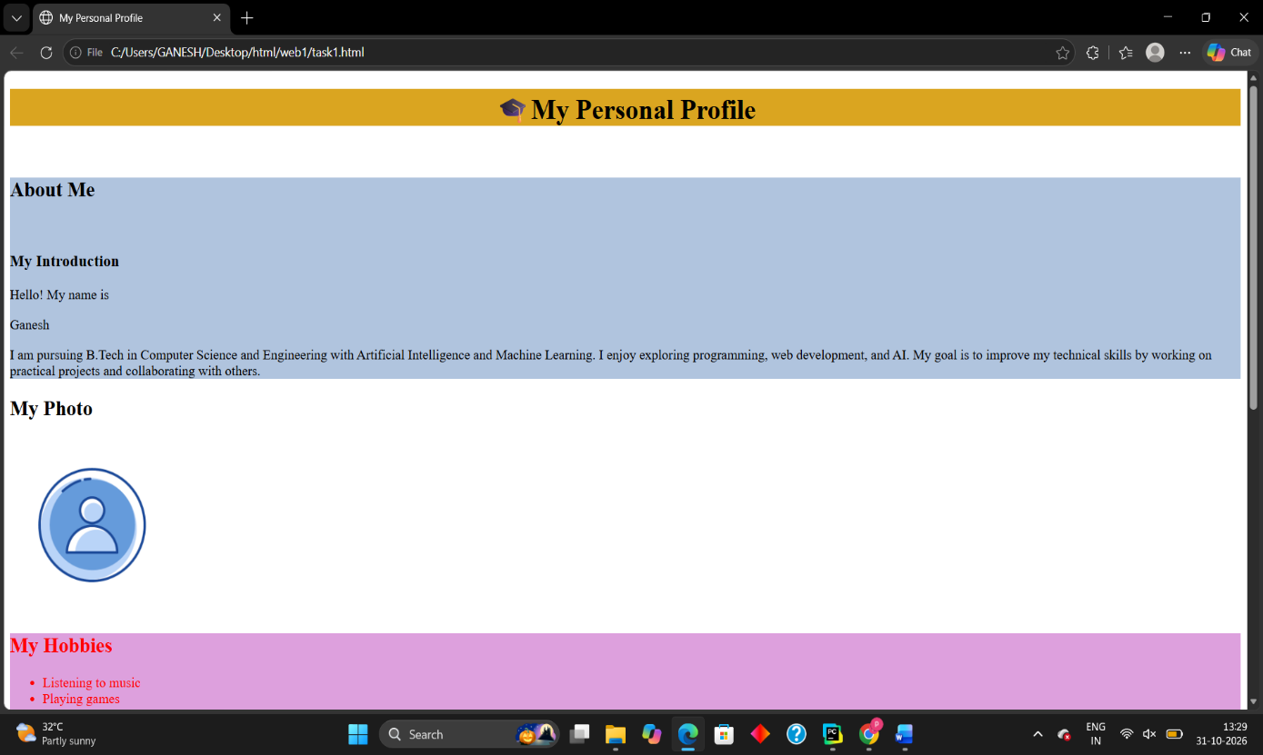
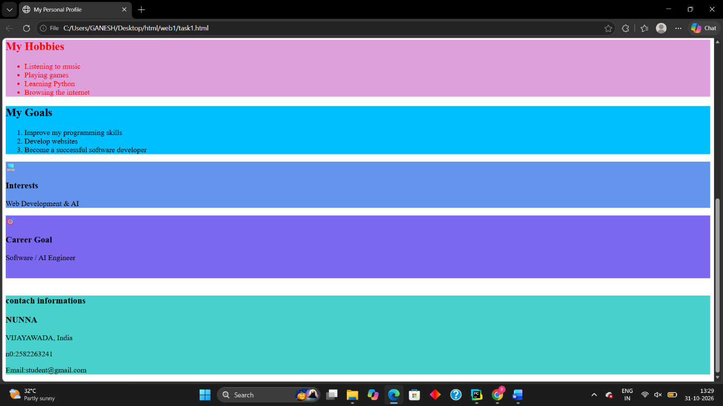
Conclusion:

Thus, a responsive personal portfolio website was successfully designed and developed using HTML and CSS
--------------------------------------------------------------------------------------------------------------

TASK 2: Travel Website

Question: Create a travel website featuring destinations, itineraries, and travel inquiry forms. Use destination cards, hero images, and responsive layouts.

Aim:

To design and develop a travel website using HTML and CSS to showcase popular destinations, travel itineraries, and inquiry forms with responsive layouts and attractive destination cards.

Source Code:
HTML CODE:
!DOCTYPE html>
<html>
<head>
<title>Explore Vijayawada</title>
<link rel="stylesheet" href="vamsi.css">
</head>
<body>

<header>
<h1>Explore Vijayawada</h1>
<p>Discover the beauty of Andhra Pradesh</p>
</header>

<section class="destination">
<h2>Welcome to Vijayawada</h2>

<img src="https://yometro.com/images/places/prakasam-barrage.jpg" height="500" width="1000">

<p>
Vijayawada is a beautiful city in Andhra Pradesh, India.
It is famous for its temples, historical places, Krishna River,
and delicious traditional food.
</p>
</section>

<section class="places">
<h2>Places to Visit</h2>
<ul>
<li>Kanaka Durga Temple</li>
<li>Prakasam Barrage</li>
<li>Undavalli Caves</li>
<li>Bhavani Island</li>
<li>Gandhi Hill</li>
</ul>
</section>

<section class="activities">
<h2>Things to Do</h2>
<ul>
<li>Visit famous temples</li>
<li>Enjoy a boat ride</li>
<li>Explore historical monuments</li>
<li>Enjoy beautiful river views</li>
</ul>
</section>

<section class="food">
<h2>Food to Try</h2>
<ul>
<li>Andhra Chicken Curry</li>
<li>Gongura Pachadi</li>
<li>Punugulu</li>
<li>Andhra Meals</li>
</ul>
</section>

<footer>
<p>Thank you for visiting! Plan your next trip to Vijayawada.</p>
</footer>

</body>
</html>
CSS CODE:
body {
background-color: #eaf7ff;
font-family: Arial, sans-serif;
margin: 0;
padding: 0;
text-align: center;
}

header {
background-color: #0077b6;
color: white;
padding: 25px;
margin-bottom: 20px;
}

h1 {
font-size: 36px;
text-align: center;
}

h2 {
color: #023e8a;
text-align: center;
}

section {
background-color: white;
margin: 20px;
padding: 20px;
border: 2px solid #90e0ef;
border-radius: 10px;
}

.destination img {
width: 80%;
max-width: 600px;
height: 300px;
object-fit: cover;
border: 3px solid #0077b6;
border-radius: 10px;
margin: 15px;
}

p {
font-size: 18px;
line-height: 1.6;
}

ul {
display: inline-block;
text-align: left;
font-size: 18px;
line-height: 1.8;
}

footer {
background-color: #023e8a;
color: white;
padding: 15px;
margin-top: 20px;
}

Output:

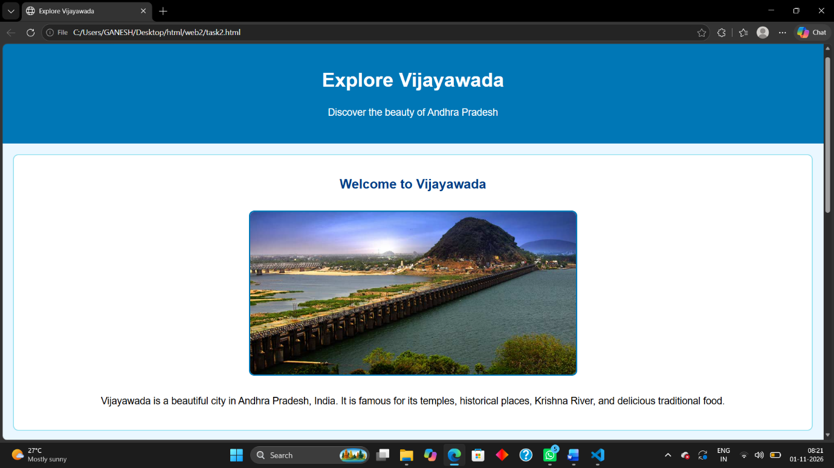
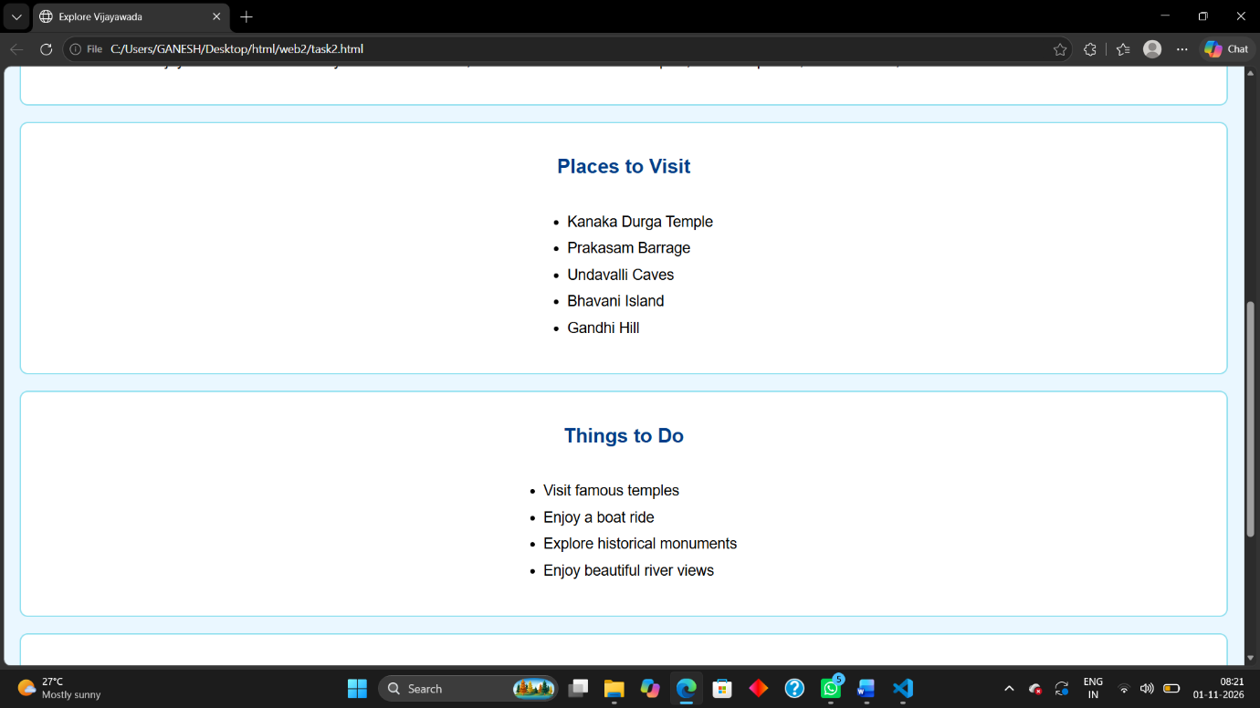
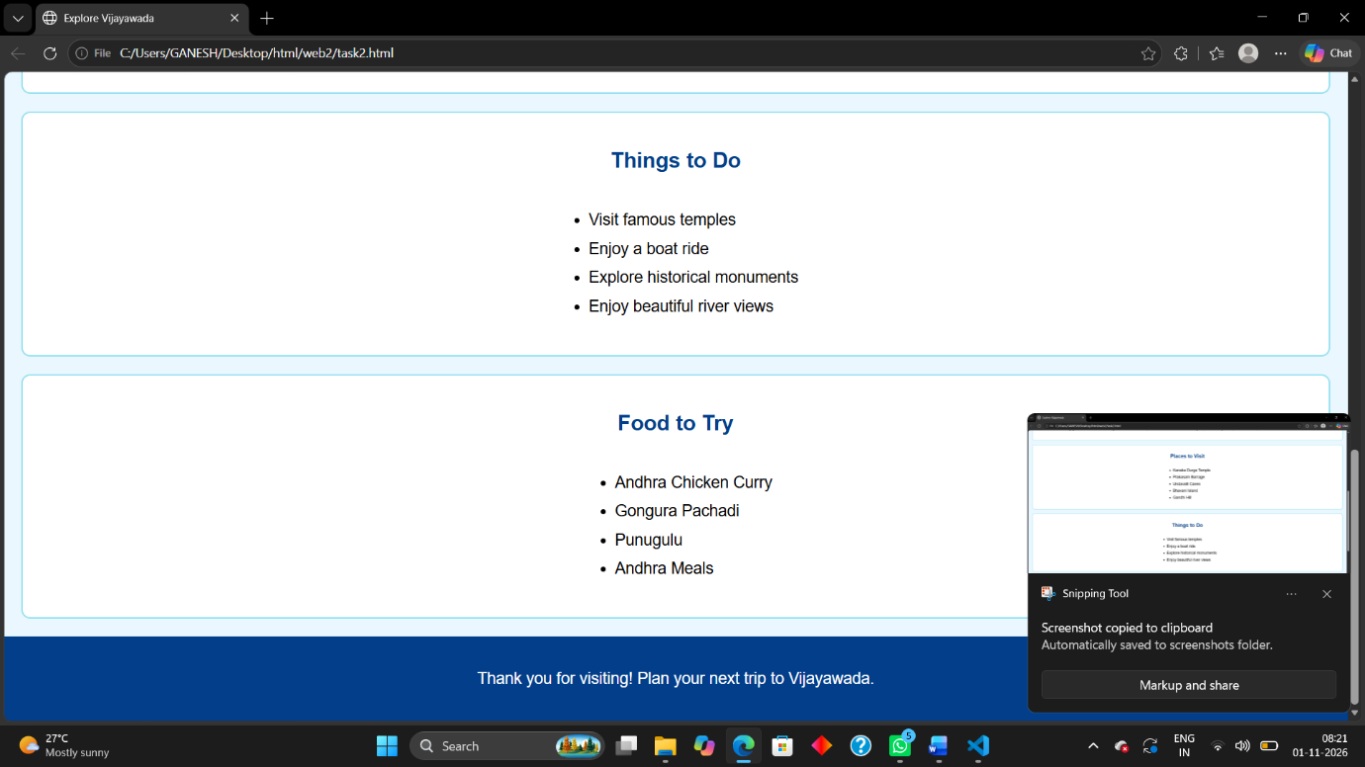
Conclusion:
Thus, a responsive travel website was successfully designed and developed using HTML and CSS.
--------------------------------------------------------------------------------------------------------------

TASK 3: College Information and Admissions Website

Question: Design a college website displaying institutional information, departments, courses, faculty profiles, admissions procedures, campus facilities, events, and contact details. Create a navigation bar, banner, and responsive information cards.

Aim:

To design and develop a college information and admissions website using HTML and CSS to display college details, departments, courses, faculty profiles, admission procedures, campus facilities, events, and contact information.

Source Code:
HTML CODE:
<!DOCTYPE html>
<html lang="en">
<head>
<title>My College Website</title>
<meta charset="UTF-8">
<link rel="stylesheet" href="aim.css">

</head>
<body>

<nav>
<h2>NRIIT university of Engineering</h2>

<a href="#home">Home</a>
<a href="#about">About</a>
<a href="#departments">Departments</a>
<a href="#courses">Courses</a>
<a href="#faculty">Faculty</a>
<a href="#admissions">Admissions</a>
<a href="#facilities">Facilities</a>
<a href="#events">Events</a>
<a href="#contact">Contact</a>
</nav>

<div class="banner" id="home">
<h1>Welcome to NRIIT university</h1>
<p>Learn Today, Lead Tomorrow!</p>
<p>Building knowledge, skills and a better future.</p>
<a href="#admissions" class="button">Join Our College</a><br><br>
<img
src="https://tse4.mm.bing.net/th/id/OIP.EIcvsZz0axp8xdtSrg_bCwHaEK?r=0&rs=1&pid=ImgDetMain&o=7&rm=3"
alt="College campus building">
</div>

<section id="about">
<h2>About Our College</h2>
<p>
NRIIT university of Engineering provides quality education
and encourages students to develop technical skills,
creativity and practical knowledge.
</p>
</section>

<section id="departments">
<h2>Our Departments</h2>

<div class="container">
<div class="card">
<h3>Computer Science</h3>
<p>Learn programming, software development and databases.</p>
</div>

<div class="card">
<h3>AI & Machine Learning</h3>
<p>Learn artificial intelligence, Python and machine learning.</p>
</div>

<div class="card">
<h3>Electronics</h3>
<p>Study electronic circuits and communication systems.</p>
</div>

<div class="card">
<h3>Mechanical</h3>
<p>Learn about machines, design and manufacturing.</p>
</div>
</div>
</section>

<section id="courses">
<h2>Our Courses</h2>

<div class="container">
<div class="card">
<h3>B.Tech CSE</h3>
<p>Computer Science and Engineering.</p>
</div>

<div class="card">
<h3>B.Tech AI & ML</h3>
<p>Artificial Intelligence and Machine Learning.</p>
</div>

<div class="card">
<h3>B.Tech ECE</h3>
<p>Electronics and Communication Engineering.</p>
</div>
</div>
</section>

<section id="faculty">
<h2>Our Faculty</h2>

<div class="container">
<div class="card">
<h3>MS. VENKATA LAKSHMI</h3>
<p>web development Professor</p>
</div>

<div class="card">
<h3>Ms. BINDHU sri</h3>
<p>AI & ML Professor</p>
</div>

<div class="card">
<h3>Mr.VENKATESWARA RAO</h3>
<p>Python Professor</p>
</div>
<div class="card">
<h3>Mr.SIVA SUBRAMANYAM</h3>
<p>computational mathematics Professor</p>
</div>

<div class="card">
<h3>MS.PRASANTHI</h3>
<p>critical thinking and logical reasoning Professor</p>
</div>

<div class="card">
<h3>Ms.SRIDEVI</h3>
<p>Professional communication Professor</p>
</div>

</div>
</section>

<section id="admissions">
<h2>Admissions</h2>
<p>Follow these steps to apply for admission.</p>

<div class="container">
<div class="card">
<h3>Step 1</h3>
<p>Choose your course.</p>
</div>

<div class="card">
<h3>Step 2</h3>
<p>Check eligibility requirements.</p>
</div>

<div class="card">
<h3>Step 3</h3>
<p>Submit your application.</p>
</div>

<div class="card">
<h3>Step 4</h3>
<p>Complete the admission process.</p>
</div>
</div>
</section>

<section id="facilities">
<h2>Campus Facilities</h2>

<div class="container">
<div class="card">
<h3>Library</h3>
<p>Books and study materials for students.</p>
</div>

<div class="card">
<h3>Computer Lab</h3>
<p>Computers for programming and practical learning.</p>
</div>

<div class="card">
<h3>Sports</h3>
<p>Facilities for games and physical activities.</p>
</div>

<div class="card">
<h3>Hostel</h3>
<p>Accommodation facilities for students.</p>
</div>
</div>
</section>

<section id="events">
<h2>College Events</h2>

<div class="container">
<div class="card">
<h3>Technical Fest</h3>
<p>Coding competitions, project displays and workshops.</p>
</div>

<div class="card">
<h3>Cultural Fest</h3>
<p>Music, dance and cultural activities.</p>
</div>

<div class="card">
<h3>Sports Day</h3>
<p>Sports competitions and team activities.</p>
</div>
</div>
</section>

<section class="contact" id="contact">
<h2>Contact Us</h2>

<p><b>Address:</b> Your College Address</p>
<p><b>Email:</b>nriit@gmail.com</p>
<p><b>Phone:</b> +91 9876543210</p>

<p>Contact the college for course and admission information.</p>
</section>

<footer>
<p>&copy; 2026 NRIIT university of Engineering</p>
<p>Designed by a First-Year B.Tech Student</p>
</footer>

</body>
</html>
CSS CODE:

body {
font-family: Arial, sans-serif;
margin: 0;
background-color: #f2f6fc;
}

nav {
background-color: #123b70;
color: white;
padding: 15px;
text-align: center;
}

nav h2 {
margin: 5px;
}

nav a {
color: white;
text-decoration: none;
margin: 10px;
display: inline-block;
}

nav a:hover {
color: yellow;
}

.banner {
background-color: #176b87;
color: white;
text-align: center;
padding: 60px 20px;
}

.banner h1 {
font-size: 35px;
}

.banner p {
font-size: 18px;
}

.button {
display: inline-block;
background-color: orange;
color: black;
padding: 10px 20px;
text-decoration: none;
border-radius: 5px;
}

section {
padding: 30px 20px;
text-align: center;
}

section h2 {
color: #123b70;
}

.container {
display: flex;
flex-wrap: wrap;
justify-content: center;
gap: 20px;
}

.card {
background-color: white;
width: 250px;
padding: 20px;
border-radius: 10px;
box-shadow: 0 2px 8px #cccccc;
}

.card h3 {
color: #176b87;
}

.contact {
background-color: #e0eaf5;
}

footer {
background-color: #123b70;
color: white;
text-align: center;
padding: 15px;
}

@media (max-width: 600px) {
nav a {
margin: 6px;
font-size: 14px;
}

.banner h1 {
font-size: 27px;
}

.card {
width: 100%;
max-width: 300px;
}
}

Output:
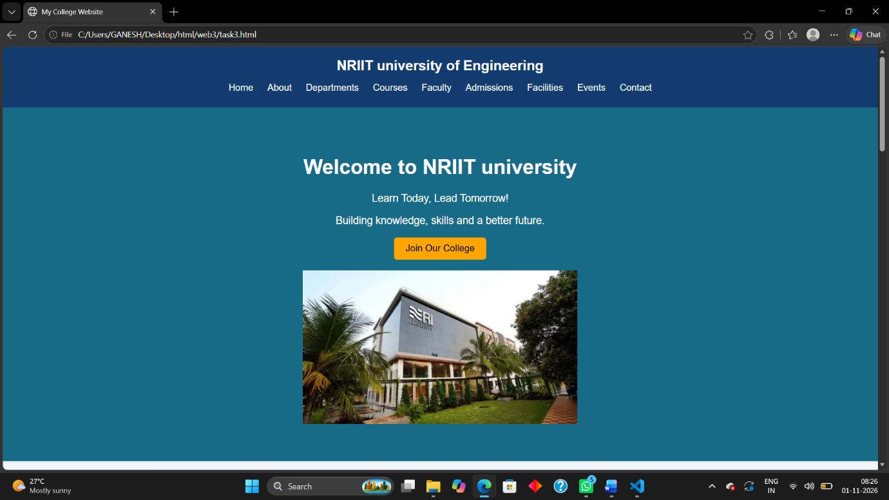
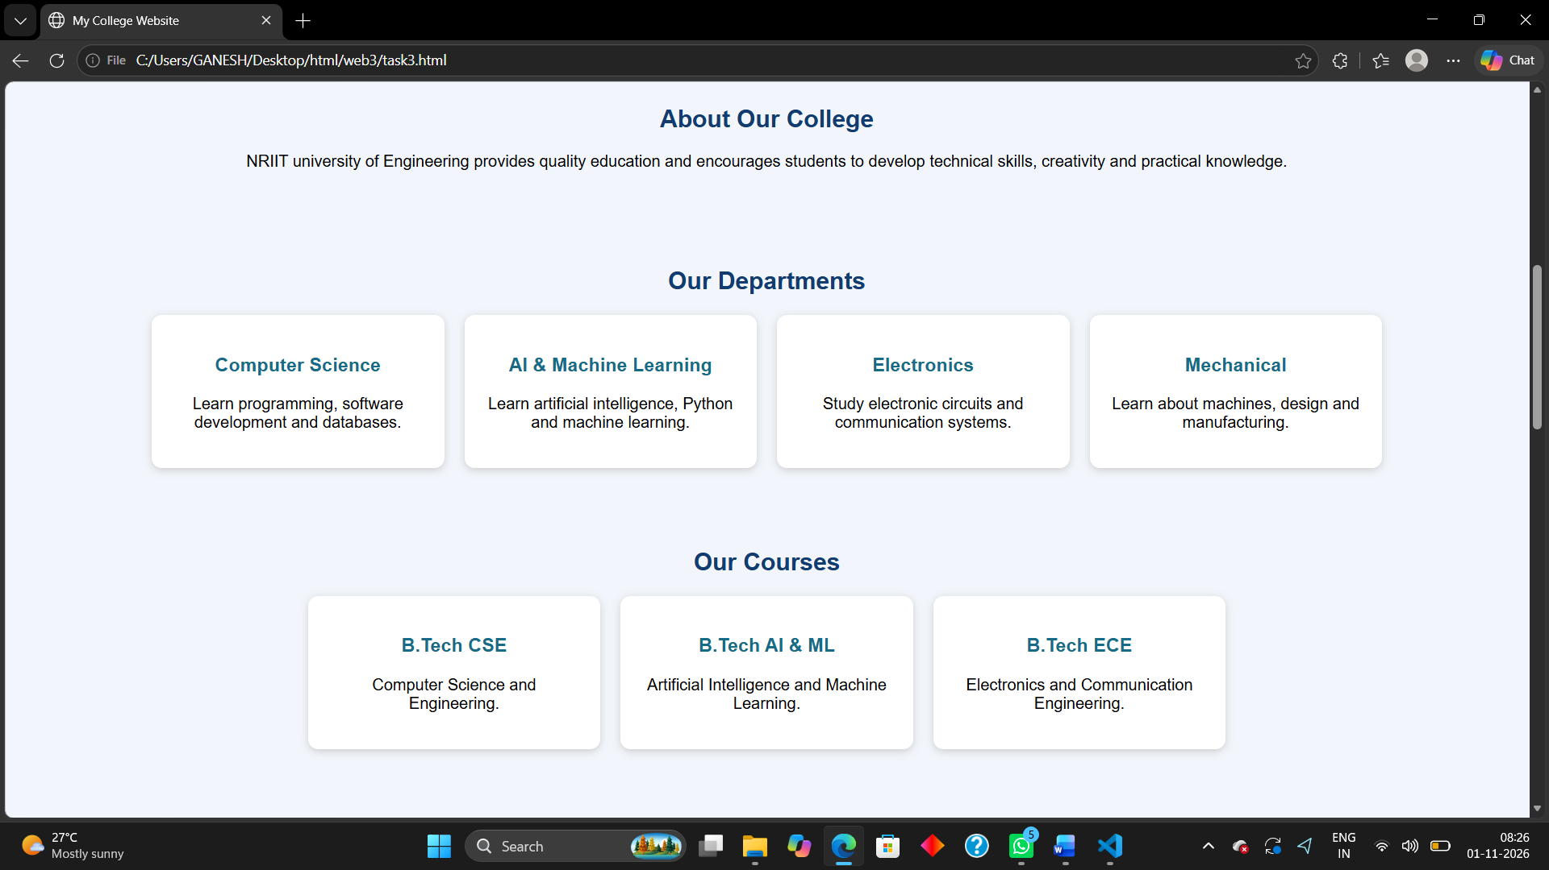
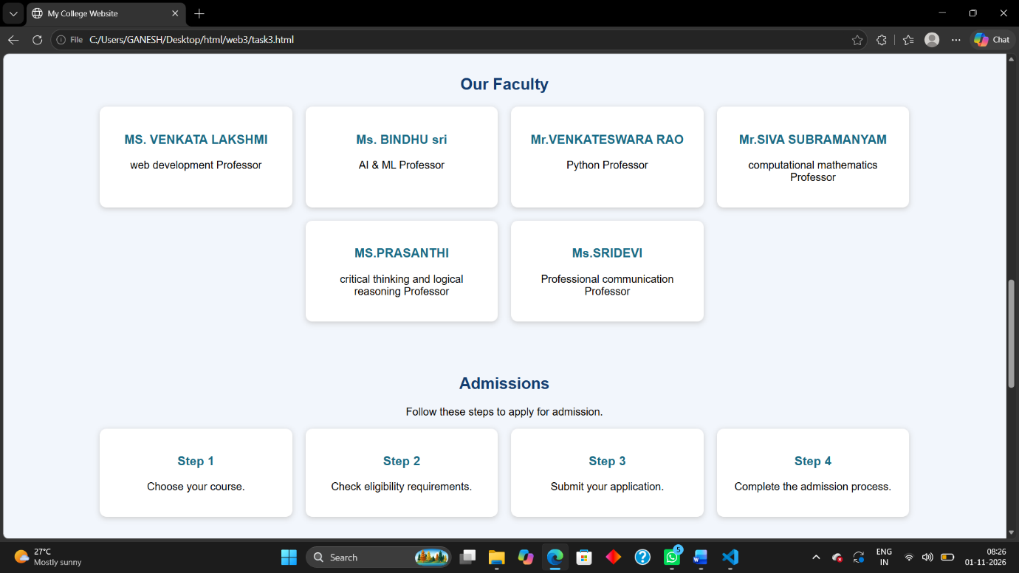
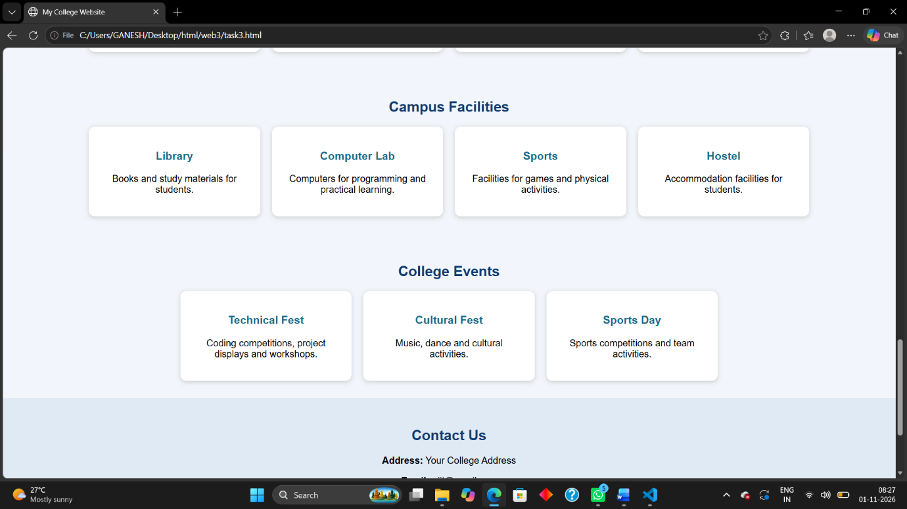
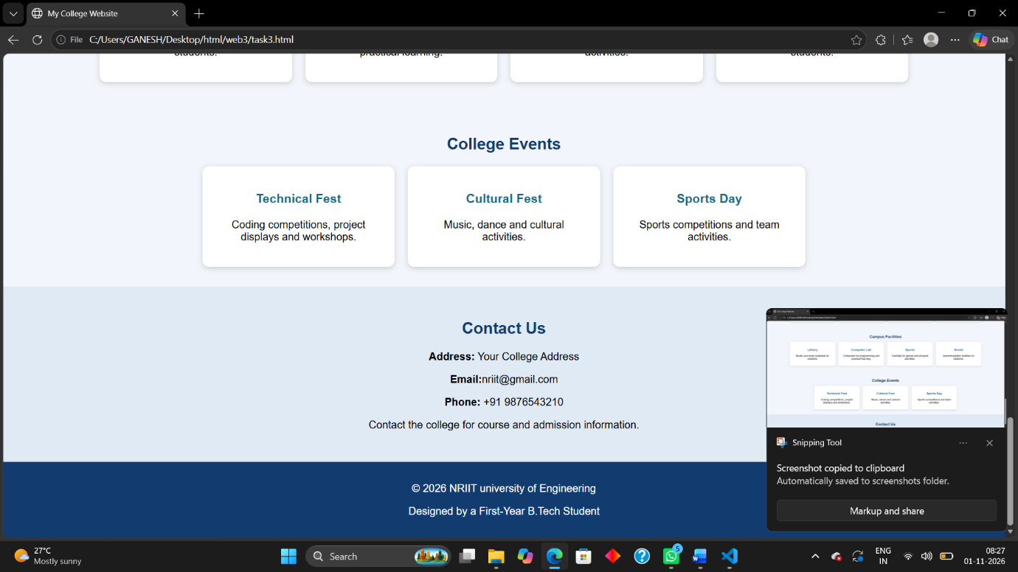
Conclusion:

Thus, a responsive college information and admissions website was successfully designed and developed using HTML and CSS.

